Caswell Council for the Arts
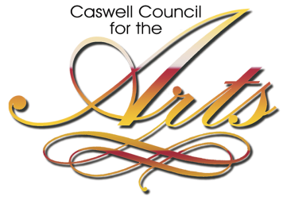
38th Juried Art Show

Eligibility
Adult artists (18 years or older) throughout North Carolina and Virginia are invited to enter the 38th juried art show sponsored by the Caswell Council for the Arts.
This show is limited to traditional two-dimensional artwork: Three dimensional work, photography and digital prints are not accepted. Any digital art images must be completely original or significantly enhanced, altered, and/or manipulated beyond the scope of a photographic image.
Awards
Cash awards and ribbons are presented at the discretion of the juror.

The following awards will be made:
Best in Show $300
First Place $200
Second Place $150
Third Place $100
Best Piece by a Caswell County
Native or Resident $100

‘Honorable Mentions’ may be made at the discretion of the juror, but carry no monetary value.

Juror: Paul Minnis

Calendar
Deadline for Entries - Delivery of Work:
Tuesday & Wednesday, September 4th & 5th
10:00 AM - 3:00 PM

Opening Reception:
Sunday, September 9th, 2:00 – 4:00 PM

Pick-Up Works Declined: Tuesday, Sept. 11th 10:00 AM – 2:00 PM

Exhibition on Display:
Sunday, September 9th thru Thursday, October 4th

Exhibition Pick-Up:
Fri, Oct 5th & Tues, Oct 9th 10:00 AM– 3:00 PM

Entries
- All entries must be completely original work by the entering artist, created within the past three years, and never previously entered in Caswell’s Juried Art Show.
- All works must be framed and/or wired for hanging.
Entry Fees
Current Members of Caswell Council for the Arts: $20 per artist for a maximum of two (2) pieces.

Non-Members: $25 per artist for a maximum of two (2) pieces.

Registration & Delivery of Work
All works must either be hand-delivered to the Caswell Council for the Arts, 43 W. Main Street in Yanceyville, NC 27379 on Tues. or Wed, September 4 or 5th from 10am – 3pm or shipped pre-paid to CCFTA PO Box 689, Yanceyville, NC to arrive by:

Wednesday, September 5th entry deadline
at 3:00 PM

- All works must have a permanent identification label attached to the back of each piece, and must be accompanied by the non-refundable entry fee.
- Shipped entries will be accepted provided they are sent in reusable containers and artist assumes full responsibility for pre-paid shipping costs to and from the Caswell Council for the Arts.
- Works not accepted for exhibition may be picked up on Tuesday, September 11th from 10:00 AM until 2:00 PM.
- Following the exhibition, all works must be picked up between 10:00 AM and 2:00 PM on Friday, October 5th or between 10:00 AM and 3:00PM Tuesday, October 9th. The Caswell Council for the Arts will not be responsible for any work left after that date.
Exhibition
Winners and selected entries will be exhibited at the Lee Fowlkes Gallery at 43 W. Main St., Yanceyville, NC September 9th – October 4th.

Sales & Commissions
- All works entered should be available for sale.
- The Caswell Council for the Arts will encourage the sale of works exhibited and collect 25% commission on any and all works sold.
- All works accepted will be displayed and available for sale during the opening reception on Sunday, September 9th from 2:00 – 4:00 PM, and will remain on display at the Lee Fowlkes Gallery at
43 W. Main St. in Yanceyville, NC through Thursday, October 4th.
- The Gallery is open to the public Tuesday through Friday from 10:00 AM to 2:00 PM, and during special events.
Deadline for Entries Wed. September 5th 3pm
For additional information please contact Denise Burnette at (336) 694-4474, caswellarts@gmail.com, or visit us online at www.ccfta.org
Opening Reception
All are invited to join us for an opening reception on Sunday, September 9th from 2pm – 4pm
Liability & Responsibility
- All reasonable care will be taken in the handling and display of entries, and all works exhibited are covered under a blanket all-risk policy during the period of the exhibition.
- The Caswell Council for the Arts will not be responsible for works not picked up by Tuesday, October 9th, 2018.
- All accepted, exhibited entries must remain on display for the duration of the show.
- The Caswell Council for the Arts reserves the right to withdraw any works which are, in their opinion, unsuitable for public display.
- Unless otherwise specified, the right to reproduction for publicity purposes without charge is assumed.

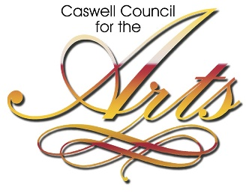 | PO Box 689  Yanceyville, NC 27379

IDENTIFICATION CARD

Artist___________________________________________________________________________

Street Address____________________________________________________________________

City _______________________________________________State___________ZIP___________

Phone_______________________________ Cell__________________________

E-Mail Address: __________________________________________________________________

Entry Fee Amount Enclosed _____________ Are you a Caswell resident or native y/n_________

TITLES OF ENTRIES

1. ___________________________________________________________________________________

2. ____________________________________________________________________________________

_________________________________
Title

__________________________________
Artist

__________________________________
Medium

_________________________________
Selling Price

________________________________
Title

__________________________________
Artist

__________________________________
Medium

_________________________________
Selling Price

